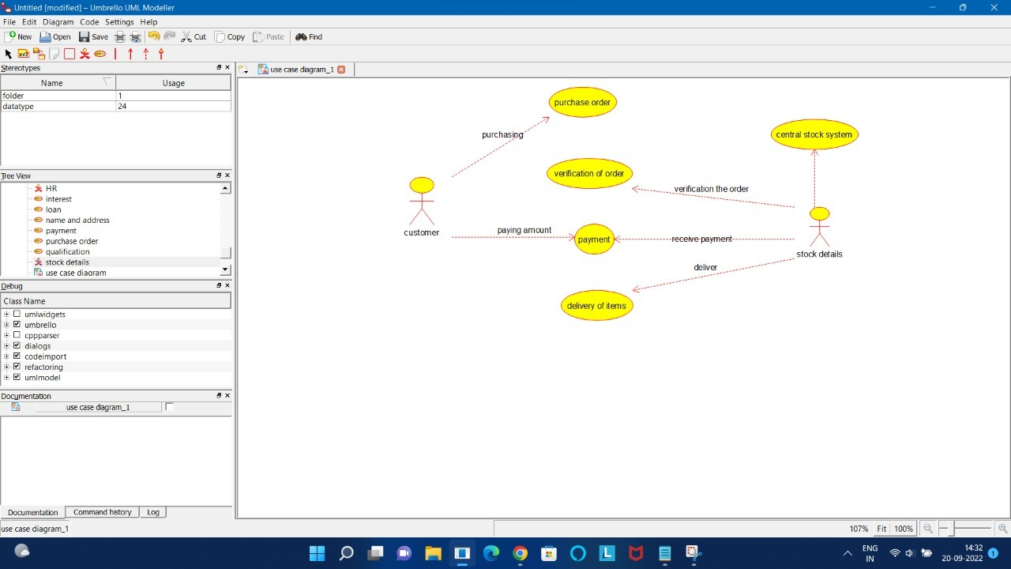

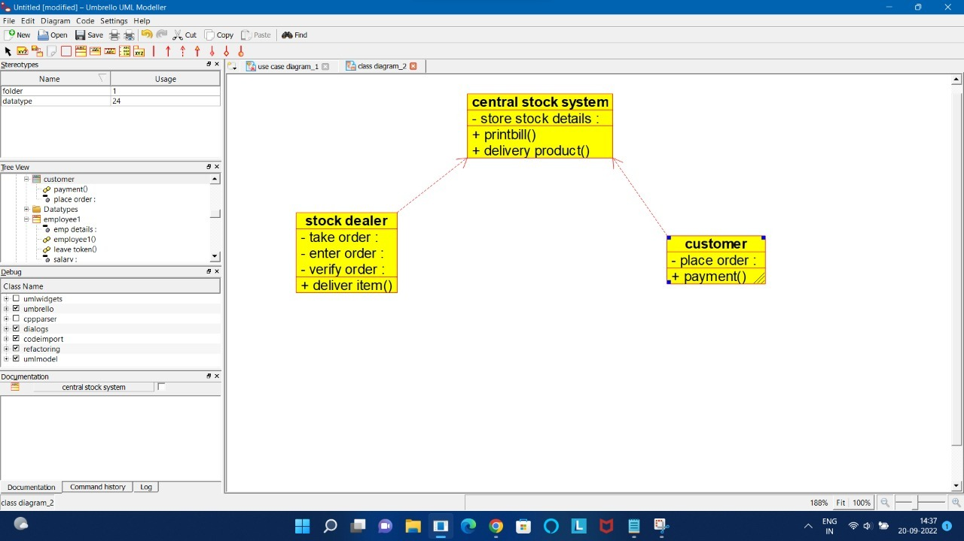

/**

* Class customer

*/

public class customer {

//

// Fields

//

private void place_order;

//

// Constructors

//

public customer () { };

//

// Methods

//

//

// Accessor methods

//

/**

* Set the value of place_order

* @param newVar the new value of place_order

*/

private void setPlace_order (void newVar) {

place_order = newVar;

}

/**

* Get the value of place_order

* @return the value of place_order

*/

private void getPlace_order () {

return place_order;

}

//

// Other methods

//

/**

*/

public void payment()

{

}

}

/**

* Class central_stock_system

*/

public class central_stock_system {

//

// Fields

//

private void store_stock_details;

//

// Constructors

//

public central_stock_system () { };

//

// Methods

//

//

// Accessor methods

//

/**

* Set the value of store_stock_details

* @param newVar the new value of store_stock_details

*/

private void setStore_stock_details (void newVar) {

store_stock_details = newVar;

}

/**

* Get the value of store_stock_details

* @return the value of store_stock_details

*/

private void getStore_stock_details () {

return store_stock_details;

}

//

// Other methods

//

/**

*/

public void printbill()

{

}

/**

*/

public void delivery_product()

{

}

}

/**

* Class stock_dealer

*/

public class stock_dealer {

//

// Fields

//

private void take_order;

private void enter_order;

private void verify_order;

//

// Constructors

//

public stock_dealer () { };

//

// Methods

//

//

// Accessor methods

//

/**

* Set the value of take_order

* @param newVar the new value of take_order

*/

private void setTake_order (void newVar) {

take_order = newVar;

}

/**

* Get the value of take_order

* @return the value of take_order

*/

private void getTake_order () {

return take_order;

}

/**

* Set the value of enter_order

* @param newVar the new value of enter_order

*/

private void setEnter_order (void newVar) {

enter_order = newVar;

}

/**

* Get the value of enter_order

* @return the value of enter_order

*/

private void getEnter_order () {

return enter_order;

}

/**

* Set the value of verify_order

* @param newVar the new value of verify_order

*/

private void setVerify_order (void newVar) {

verify_order = newVar;

}

/**

* Get the value of verify_order

* @return the value of verify_order

*/

private void getVerify_order () {

return verify_order;

}

//

// Other methods

//

/**

*/

public void deliver_item()

{

}

}